Name = Vansh tanwar

Roll Number = 2401010102

LAB MANNUAL = 04
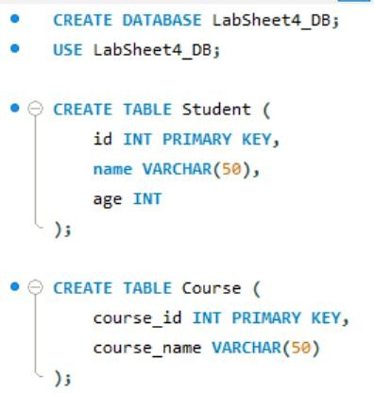

Tasks
Part A: User Creation
- Create a new user named user1 with a password.
- Create another user user2 with limited access.
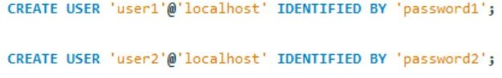

Part B: Granting Privileges
- Grant SELECT and INSERT privileges on a table Student to user1.
- Grant ALL privileges on a table Course to user2.
- Provide WITH GRANT OPTION to user1 and observe its effect.
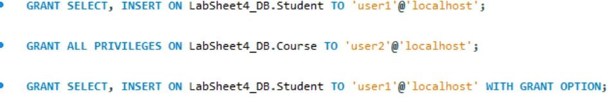

Part C: Revoking Privileges
- Revoke INSERT permission from user1 on the Student table.
- Revoke all privileges from user2 on the Course table.
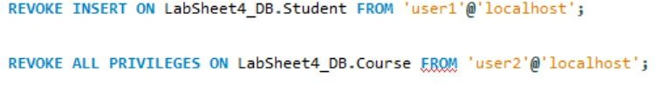

Part D: User Deletion
- Drop/Delete user user2 from the database.
- Attempt to login using deleted credentials and observe the result.
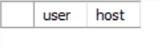

Part E: Additional Commands
- Display all users in the system.
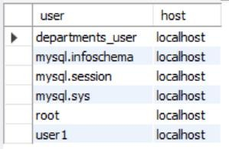

- Show privileges assigned to a specific user.
